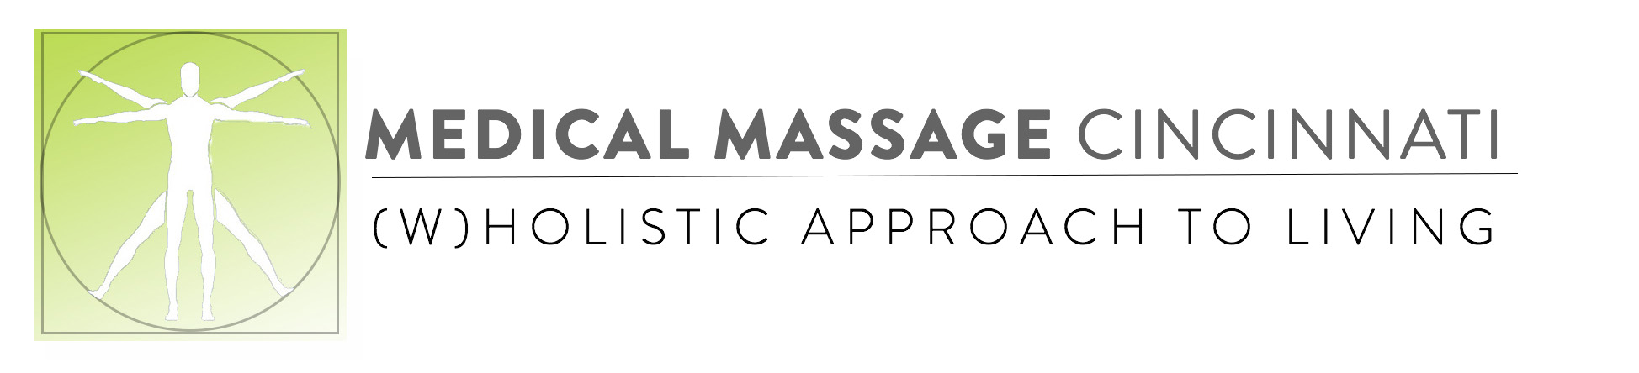
3 Day Sample Meal Plan
 | Breakfast | Lunch | Dinner | Snack
Day1 | Hearty Big Bowl & Green Glory Juice | Veggie Wrap a 1/2 cup fresh berries | Sweet Potato Kale Plate & Green Glory Juice | Cucumber chips with hummus
 |  | Lunch | Dinner | Snack
Day 2 | Avo Toast & Green Glory Juice | White Bean Avocado Salad | Zucchini Spaghetti with Homemade Italian sauce & Green salad | 1/8 cup of raw Almonds OR Frozen Fruit
 | Breakfast | Lunch | Dinner | Snack
Day 3 | Over night Oats & Green Glory Juice | Spinach + Hummus Sammie Dill Spears | Rice from day 1 and sauce from day2 & Green Glory Juice | Pepper and cucumbers slices with 1/8 cup raw Almonds

www.medicalmassagecincinnati.com

